RESOLUTION NO.__________

RE: CERTIFICATE OF APPROPRIATENESS UNDER THE
PROVISIONS OF THE ACT OF THE PENNSYLVANIA
LEGISLATURE 1961, JUNE 13, P.L. 282 (53
SECTION 8004) AND BETHLEHEM ORDINANCE NO.
3952 AS AMENDED.

WHEREAS, it is proposed to replace the existing slate roof with GAF Slateline shingles and remove a brick chimney at 257 E. Church St.

NOW, THEREFORE, BE IT RESOLVED by the Council of the City of Bethlehem that a Certificate of Appropriateness is hereby granted for the proposal.

Sponsored by: (s)

(s)

ADOPTED BY COUNCIL THIS DAY OF

(s)
President of Council

ATTEST:

(s)
City Clerk

HISTORICAL & ARCHITECTURAL REVIEW BOARD

APPLICATION #4: The applicant proposes to replace the existing slate roof with GAF
Slateline shingles at 257 E. Church St.

OWNER: Morris Noretsky/Anne Pendergist
257 E. Church St., Bethlehem, PA 18018
__________________________________________________________________

The Board upon motion by Phil Roeder and seconded by Marsha Fritz adopted the proposal that City Council issue a Certificate of Appropriateness for the following:

- Re-roofing using GAF Slateline in Antique Slate color.

2. Include a shingle covered ridge vend end to end including gable overhangs.

3. Also approved a removal of a non-functioning chimney on the west end of
the roof and use of copper flashings for the remaining penetrations along with
relocation of the plumbing vent.

4. If replacing gutters they are to be half round in White with round White
downspouts. Drip edge will be copper or painted to match the wood trim

5. The motion was unanimously approved.

__________________________________________________________________________

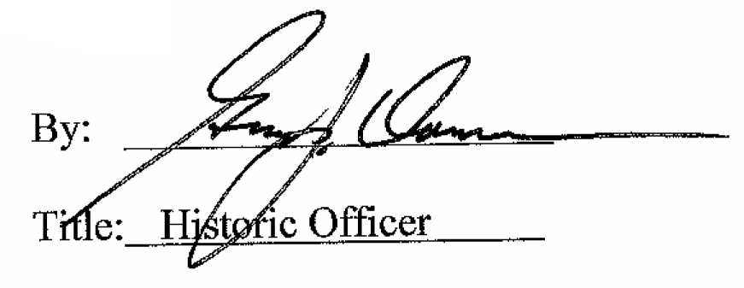

Date of Meeting: November 5, 2014

